Purpose of this document – This document aims to keep track of our approach that we have used to create the Black Litterman model portfolio.

***Process***

Time period of study – We have tried to study the portfolio allocation for the time of 07/03/2013 to 07/03/2018

ETF selection -

To start with we have chosen the best ETFs that are possible for each asset class using the following rules -

1. AUM > $1B
2. Total Expense Ratio < 0.15%
3. Spread < 0.05%
4. Avg Daily Trading Volume > $ 100 M

Based on these conditions we have selected the following ETFs from each sub-category :

|  |  |  |
| --- | --- | --- |
| **Category** | **Subcategory** | **ETF** |
| Equity | Emerging Markets – Total Markets | VWO |
| Equity | Dev Markets ex. US – Total Market | VEA |
| Equity | US Small Cap Value | VBR |
| Equity | US Mid Cap Value | VOE |
| Equity | US Large Cap Value | VTV |
| Equity | US Total Market | VTI |
| Bonds | Emerging Markets – Sovereign | EMB |
| Bonds | Broad Market ex. US – IG | BNDX |
| Bonds | US Corp IG | LQD |
| Bonds | US Broad Market IG | BND |
| Bonds | Govt Treasury Cash Equivalents | SHV |
| Bonds | US Govt TIPS Short | VTIP |

***Step 1 - Take the monthly prices of each ETF***

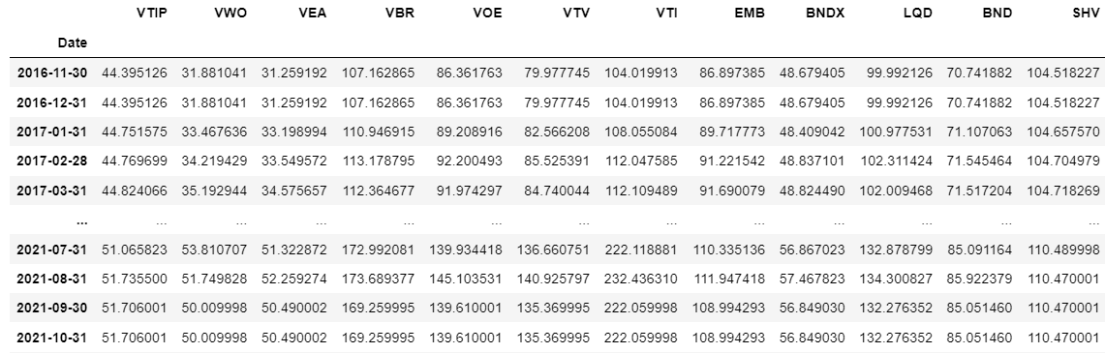**Note – We are using the monthly closing prices**

***Step 2 – Calculate the mean returns and the Shrunk Covariance for each ETF***

Mean return is the sum of the monthly returns of the ETFs selected above divided by the number of observations.

**Shrunk covariance matrix** -

Why are we using shrunk covariance compared to sample covariance?

The problem with using sample covariance is that the sample covariance is affected by outliers. Instead of reducing the impact of outliers, sample covariance is increasing the impact of the outlier as a result of which our portfolio will vary too much. So, to normalize the impact of outliers, we are using the shrunk covariance.

How to calculate the shrunk covariance?

*Step 1 – Calculate the sample covariance for all the possible combinations of ETFs using the following formula:*

**Cov(X, Y) = ∑(xi−¯x)(yi−¯y) / N**

*where x and y are the returns of all ETF calculated in previous set*

*Step 2 – Calculate the Structured Estimator*

A) Take the sum of diagonals of the sample covariance calculated in the previous step

B) Divide the sum of diagonals by the total number of observations

C) Place the value calculated along the diagonals of a zero matrix

This is the Structured Estimator.

The benefit of using a Structured Estimator is that it is much more stable when compared to the sample covariance as it is taking the covariance among different assets to be equal to zero and the variance of all the assets to be average variance of all ETFs. Basically, the average of all asset classes.

Step 3 – Use the formula below to calculate the shrunk covariance

Shrunk cov matrix = (1-delta) *Sample Cov + delta * Structured Estimator

Delta is assumed to be 0.0295

How do we calculate delta?

Delta is a co-efficient that is derived after optimizing or reducing the distance between the Structured Estimator and the sample covariance. **(Think of this as weights)**

*Explanation of shrunk covariance in loose terms – Shrunk covariance is kind of mix of the smart averaging and weighting coefficients, and the main idea is to decrease spurious variances by recalculating them with averaged values where each values has its own intensity.*

***Step 3 – Calculate the risk aversion of general investor in the market***

Why do we need risk aversion?

Every asset in the market portfolio contributes a certain amount of risk to the portfolio. Hence, investors must be compensated for the risk that they take, so we can attribute to each asset an expected compensation (i.e prior estimate of returns).

Steps to calculate the risk aversion

To compensate the investor, we need to calculate how averse the investor is to variation in the portfolio. We can calculate the general risk aversion of the market by using the prices of SPY and are using the steps given below :

1. Take the daily prices of SPY which is the price of SPDR SNP500 ETF - SPY is SNP 500 ETF and can be considered as the good approximation of the market, in general.
2. Calculate the returns
3. Calculate the risk aversion with the formula -

**Risk Aversion = (R – Rf) / Variance**

*where**R is the return on portfolio and Rf is the risk free rate*

***Step 4 – Calculate the weights of each ETF based on the market cap***

Why do we need weights of each ETF based on market cap?

The purpose of calculating ratio of market cap of ETFs is to build an equilibrium portfolio. An equilibrium portfolio is such that we should have no assumption on how the market will perform and we will just see where the people are investing money and we belief the consensus belief of people is enough guidance as to how we want to build the portfolio.

Formula to calculate the weights of each ETF

**Weight of ETFi = Market cap of ETFi / Total Market Cap of all ETFs**

***Step 5 – Calculate implied market prior returns -***

What is market prior returns?

You can think of the prior as the “default” estimate, in the absence of any information. Black and Litterman provide the insight that a natural choice for this prior is the market’s estimate of the return, which is embedded into the market capitalization of the asset.

Formula of market prior returns

**Market prior returns = Risk Aversion * matrix of weight of ETFs * Shrunk covariance matrix**

***Step 6 – Take analyst views on the returns***

So, returns that we have calculated till now are under the assumption that we have no opinion on how the market will perform in the future. But that is not true and, in this step, we will introduce the analyst views into the model.

For the time being we have assumed the following weights. This is an assumption for the time being.

Viewdict ={'VTIP':0.0185,'VWO':0.0705,'VEA':0.0329,'VBR':0.0974,'VOE':0.0955,'VTV':0.0894,'VTI':0.0924,'EMB':0.055,'BNDX':0.0347,'LQD':0.0567,'BND':0.0402,'SHV':0.0094}

This is the Annualised returns of the selected ETFs since inception

***Step 7 – Now pass the analyst view, market prior returns to calculate the weights using Black Litterman approach***

Once we have collected the view of each analyst, we use the following formula to calculate the Black Litterman as a product of shrunk covariance matrix, market prior and view_dict

***Step 8 – Calculate the Efficient Frontier using MPT*** -

Once the portfolio weights using the BL model are calculated, we are using the weights calculated in the BL model as inputs to calculate returns.

These returns become an input into the MPT model. MPT model aims to tweak the portfolio in such a way that they Sharpe Ratio of the portfolio is maximised I.e. find the portfolio on the efficient frontier.

Add the following constraint to the MPT model-

1. Short sale constraint - weight of ETFi >= 0
2. Maximum Weight constraint – Between 0 and 1

The optimizer will change weights of the portfolio is such a manner that formula given below is maximized

**Sharpe Ratio = Expected (Return Portfolio – Risk free rate) / sigma Portfolio**

Step 10 – Take the weights of each ETF for each maximum weight constraint, stack them up (using cumsum) and plot the same

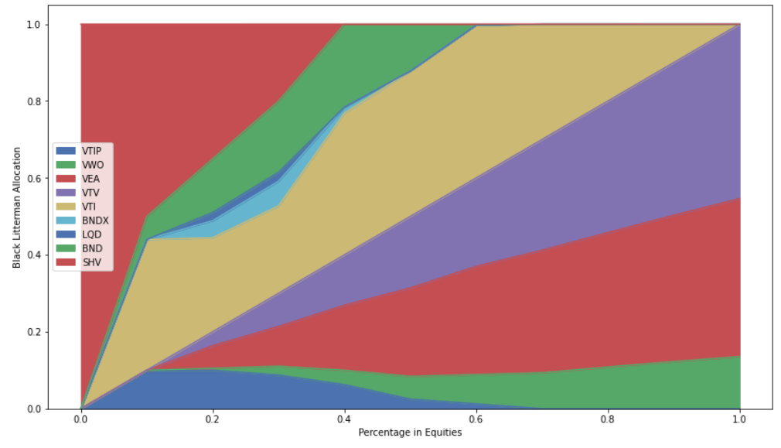

***Results of various tests conducted***

**1 year test**

**Market prior**

|  |  |  |  |  |  |  |
| --- | --- | --- | --- | --- | --- | --- |
|  | VWO | VEA | VBR | VOE | VTV | VTI |
| 2013 | 100% |  |  |  |  |  |
| 2014 | - |  |  |  |  |  |
| 2015 | 80% |  |  | 20% |  |  |
| 2016 | 100% |  |  |  |  |  |
| 2017 | 100% |  |  |  |  |  |
| 2018 | 35% |  |  |  |  | 65% |
| 2019 | 60% |  |  |  |  | 40% |
| 2020 | 20% | 20% | 35% | 5% |  | 20% |
| 2021 |  |  |  |  |  | 100% |

**Market prior and view_dict**

|  |  |  |  |  |  |  |
| --- | --- | --- | --- | --- | --- | --- |
|  | VWO | VEA | VBR | VOE | VTV | VTI |
| 2013 | 5% |  | 15% | 30% | 25% | 25% |
| 2014 | 5% |  | 5% | 70% | 20% |  |
| 2015 |  |  |  | 60% |  | 40% |
| 2016 | 10% |  |  | 30% |  | 60% |
| 2017 | 10% |  | 30% | 10% |  | 50% |
| 2018 |  |  |  |  | 25% | 75% |
| 2019 |  |  |  | 20% |  | 80% |
| 2020 |  |  |  |  | 2% | 98% |
| 2021 |  |  |  | 10% |  | 90% |

**Based on discussions on 18th December 2021**

**From MPT to Black Litterman**

*From the document named : Idzorek on BL*

* Created by Fisher Black and Robert Litterman
* Overcomes problems of unintuitive, highly-concentrated portfolios, input sensitivity and estimation error maximisation
* The Black Litterman model combines the CAPM, reverse optimization , mixed estimation, the universal hedge ratio / Black’s global CAPM, and mean-variance optimization

**Sensitivity of MVO and how reverse optimisation mitigates the problem**

* Most important input in MVO is expected returns however Best and Grauer demonstrate that a small increase in E(R) can force half of the assets from the portfolio. BL tried multiple approaches to calculate the E(R) like historical returns, equal ‘mean’ returns for all portfolios, risk adjusted equal mean returns and so on. These lead to extreme portfolios with concentration on small number of assets
* They finalised on equilibrium returns as a neutral starting point
* Equilibrium returns are derived using a reverse optimization method

Vector of implied excess returns (π) = Risk aversion coefficient * covariance matrix * Wmcap

The aim of BL approach is to find the weights, so we can reverse optimize the above formula to find the weights for the portfolio

The following are the returns that we have got from three different approaches -

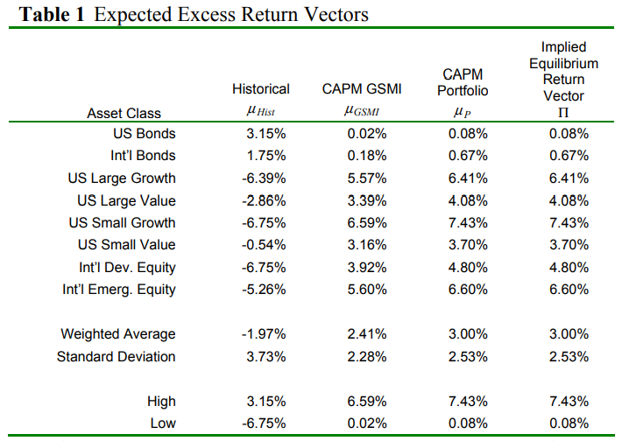

Now let's rearrange the formula -

(Vector of implied excess returns (π)/ Risk aversion coefficient * covariance matrix) = Wmcap

If we don’t know the implied excess return, w != wmcap

Following the answer that we get from reverse optimisation -

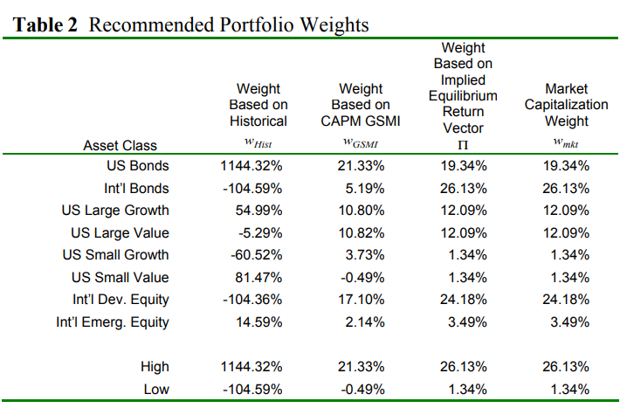

* Historical return produces an extreme portfolio
* In the absence of views, investors should hold market portfolio

***The BL Model***

K – number of views

N – number of assets

E(R) = [(Tau * covariance matrix)-1 + (P’ * Uncertainty matrix * P)]-1 * [(Tau * covariance matrix * Implied Equilibrium Return Vector)-1 + (P’ * Uncertainty matrix * Q)]

**View vector (Investor views – Q)**

Analysts' views can be expressed in absolute or relative terms

**View 1 – International Developed Equity will have an absolute excess return of 5.25% (Confidence of view = 25%)**

**View 2: International Bonds will outperform US Bonds by 25 basis points (Confidence of View = 50%).**

**View 3: US Large Growth and US Small Growth will outperform US Large Value and US Small Value by 2% (Confidence of View = 65%)**

View 1 is an absolute view

View 2 -

Implied return from Table 1 shows that Intl’ Bonds have an implied equilibrium return of 0.67% and US Bonds have an implied equilibrium returns of 0.08% which means Intl Bond will outperform US Bonds by 0.59%

Our view states that Intl’ Bond will outperform by 0.25% only, hence there will be a tilt from Intl’ Bond to US Bond

View 3 – Multiple asset views

Our view is that US Large Value and US Small Value will outperform US Large Growth and US Small Growth by 2%

Implied returns from Table show that the weighted average implied return of US Large Value and US Small Value is 6.52%

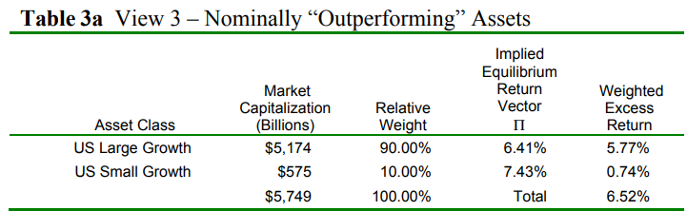

Implied returns from Table show that the weighted average implied return of US Large Growth and US Small Growth is 4.04%

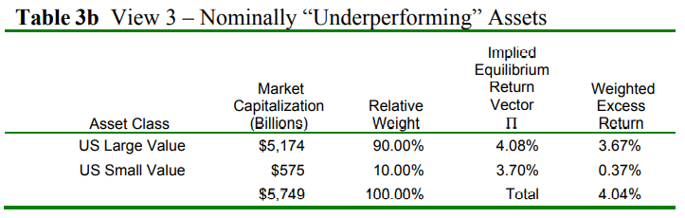

Hence the differential being 2.47%

As the differential < view, tilt from growth towards value

Building the inputs -

1)

* The model does not require that investor specify views on all assets
* In this example we have only 3 views on a total of 8 assets

2) Total view is

Q+ E = [Q1 [E1

. .

. + .

. .

Qk] Ek]

Where Q is the view matrix

E is the uncertainty of views

E does not enter the model. The variance of each error term which is the absolute difference from the error term expected value enters the formula.

The variance of the error term for covariance matrix structured estimator

Structured Estimator is a diagonal covariance matrix with 0’s in all the off-diagonal positions and in the diagonals we have variance of error terms

The off diagonals are 0 because the model assumes that the views are independent of each other

The variance in error terms of views represent uncertainity in views. Larger the variance of the error term, greater is the uncertainity of the view

Structured Estimator will look like -

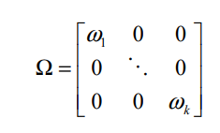

**3) Finding the individual variances of the error terms**

**4) *Q is matched to specific assets by matrix P***

Q – 1 * N matrix

Suppose we have 3 views

P – 3 * N matrix

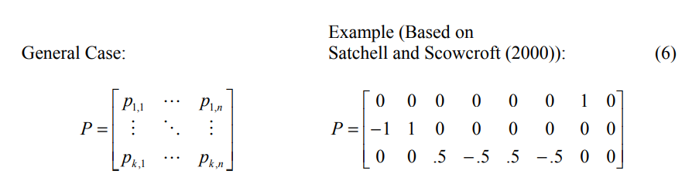

First row is absolute views

Second and third rows are relative views where the sum of views is equal to 0

Mathods for specifying the values of P vary for different authors

Satchel and Scowcroft use equal weighting scheme. But this model has its disadvantages. We prefer to use the market cap approach.

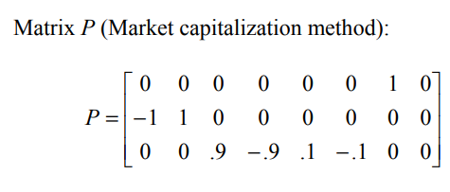

From the third column of Tables 3a and 3b, the relative market capitalization weights of the nominally outperforming assets are 0.9 for US Large Growth and 0.1 for US Small Growth, while the relative market capitalization weights of the nominally underperforming assets are -.9 for US Large Value and -.1 for US Small Value. These figures are used to create a new Matrix P

**Now P is defined.**

**5) Using the P above lets calculate the variance of each individual view using the formula**

**Pk * cov matrix * Pk’**

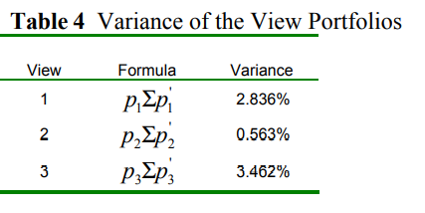

This forms the diagonals of structured estimator

**Conceptually BL model is complex weighted average of Implied Equilibrium Return Vector and the View Vector in which the relative weightings are the function of Tau and uncertainity of views**

**Unfortunately, the scalar and the uncertainty in the views are abstract and difficult to specify in the model. The greater the level of the confidence, closer will be the new returns to the views. If the investor is less confident in the expressed views, the new returns will be closer to the Implied Equilibrium Return Vector**

**Implied Equilibrium Return Vector <----------------------------------------------------------> View vector**

**function of Tau and uncertainity in views**

* The magnitude of their departure from their market capitalization weight is controlled by the ratio of the scalar (τ ) to the variance of the error term (ω ) of the view in question.
* The variance of the error term (ω ) of a view is inversely related to the investor’s confidence in that view. Thus, a variance of the error term (ω ) of 0 represents 100% confidence (complete certainty) in the view

As per He and Litterman, confidence is the ratio of

ω/ τ = Variance of view portfolio (Pk * cov * Pk’)

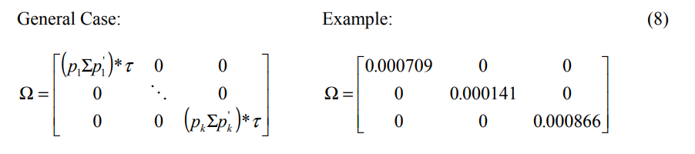

Advantage of this approach - changing the assumed value of the scalar (τ ) from 0.025 to 15 dramatically changes the value of the diagonal elements of Ω , but the new Combined Return Vector ( ] E[R ) is unaffected.

**6) Value of Tau**

* Tau is inversely proportional to the relative weight given to the Implied Equilibrium Return Vector .
* Since the uncertainty in the mean is less than the uncertainty in the return, the scalar (τ ) is close to zero. One would expect the Equilibrium Returns to be less volatile than the historical returns.
* Lee, who has considerable experience working with a variant of the BlackLitterman model, typically sets the value of the scalar (τ ) between 0.01 and 0.05, and then calibrates the model based on a target level of tracking error.
* Satchell and Scowcroft (2000) say the value of the scalar (τ ) is often set to 1.
* Blamont and Firoozye interpret τΣ as the standard error of estimate of the Implied Equilibrium Return Vector (Π ); thus, the scalar (τ ) is approximately 1 divided by the number of observations.

7) Calculation of the New Combined Return Vector

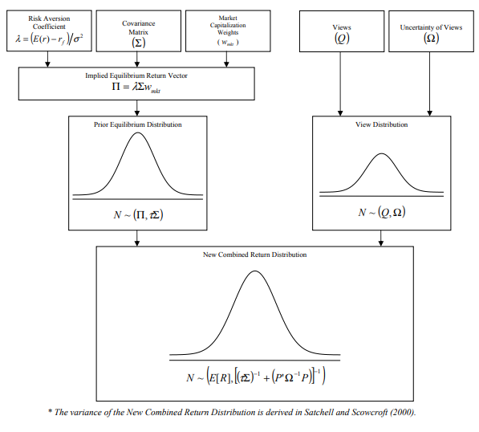

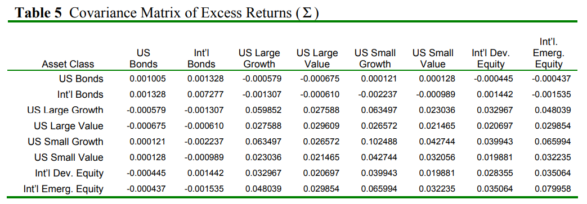

A single view causes the return of every asset in the portfolio to change from its Implied Equilibrium return, since each individual return is linked to the other returns via the covariance matrix of excess returns (Σ ).

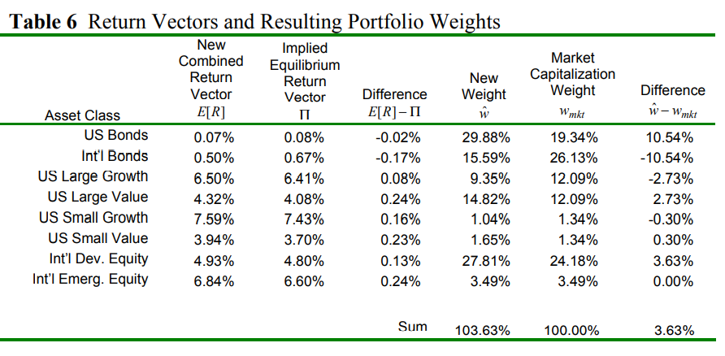

The New Weight Vector (wˆ ) in column 5 of Table 6 is based on the New Combined Return Vector E[R ).

One of the strongest features of the Black-Litterman model is illustrated in the final column of Table 6. Only the weights of the 7 assets for which views were expressed changed from their original market capitalization weights and the directions of the changes are intuitive.

No views were expressed on International Emerging Equity and its weights are unchanged.

**Codes reconciliation of BL and MVO**

**Steps in PyportfolioOpt code for MVO**

1) Download price data

tickers **=** ["MSFT", "AMZN", "KO", "MA", "COST", "LUV", "XOM", "PFE", "JPM", "UNH", "ACN", "DIS", "GILD", "F", "TSLA"]

ohlc **=** yf**.**download(tickers, period**=**"max")

prices **=** ohlc["Adj Close"]**.**dropna(how**=**"all")prices**.**tail()

2) Calculate the sample covariance

sample_cov **=** risk_models**.**sample_cov(prices, frequency**=**252)sample_cov

3) Calculate the Covariance Shrinkage (for reasons discussed above)

S **=** risk_models**.**CovarianceShrinkage(prices)**.**ledoit_wolf()

plotting**.**plot_covariance(S, plot_correlation**=True**)

4) Calculate the CAPM returns(slightly more stable than the default mean historical return)

mu **=** expected_returns**.**capm_return(prices)

Mu

4) Construct a long/short portfolio with the objective of minimising variance. There is a good deal of research that demonstrates that these global-minimum variance (GMV) portfolios outperform mean-variance optimized portfolios.

S **=** risk_models**.**CovarianceShrinkage(prices)**.**ledoit_wolf()

*# You don't have to provide expected returns in this case*

ef **=** EfficientFrontier(**None**, S, weight_bounds**=**(**None**, **None**))

ef**.**min_volatility()

weights **=** ef**.**clean_weights()

weights

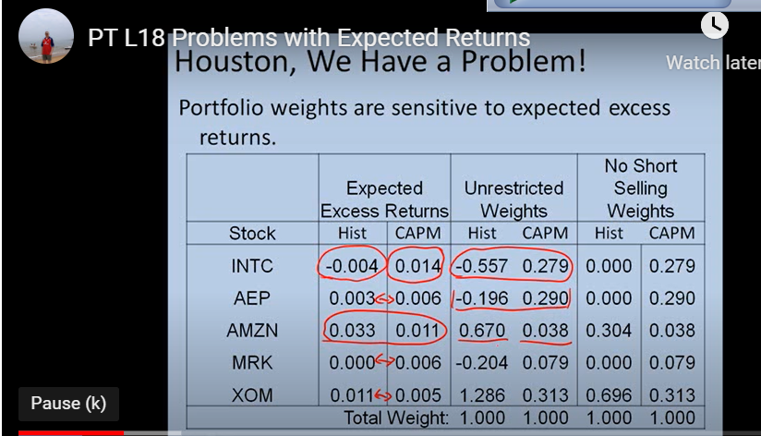

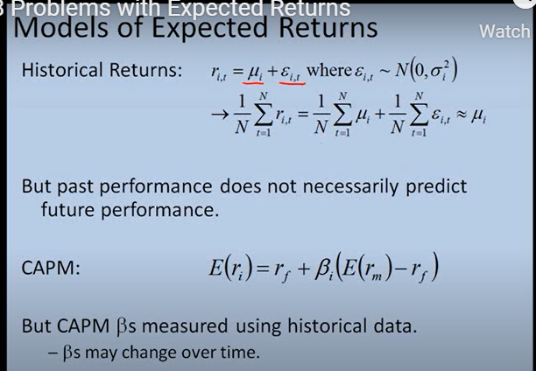

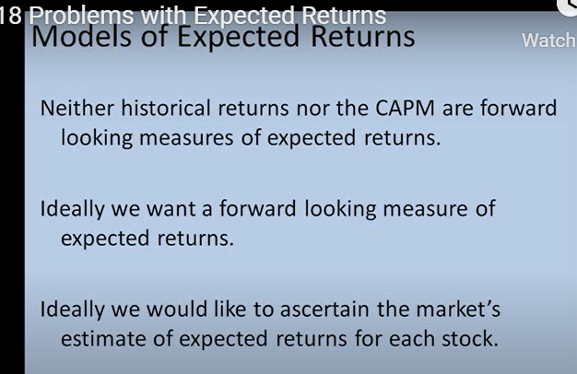

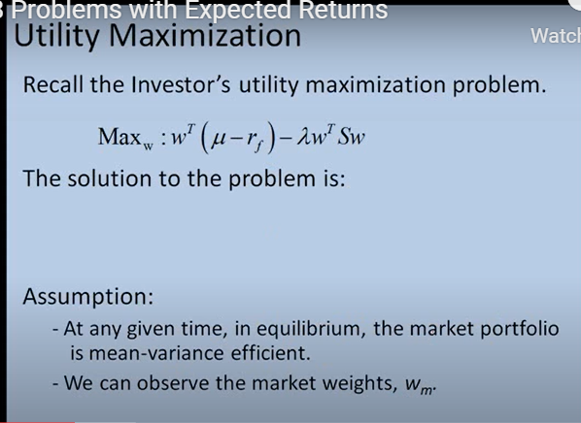

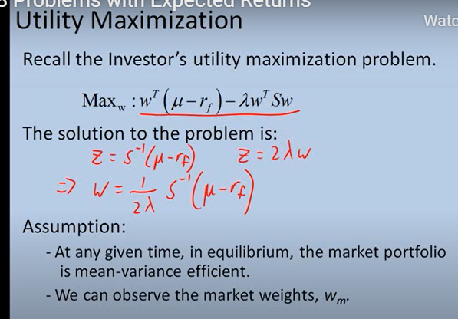

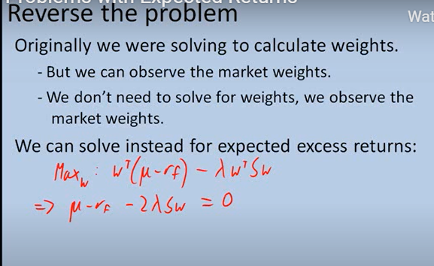

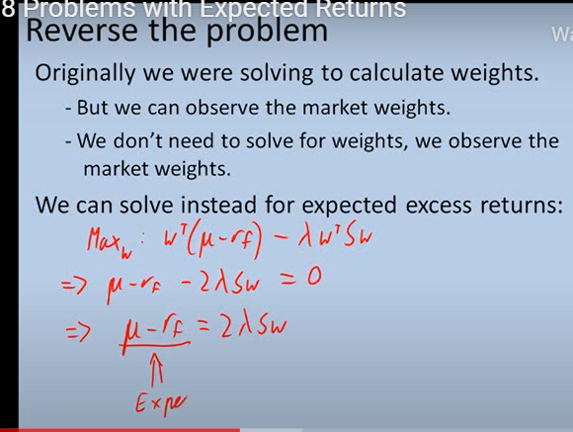

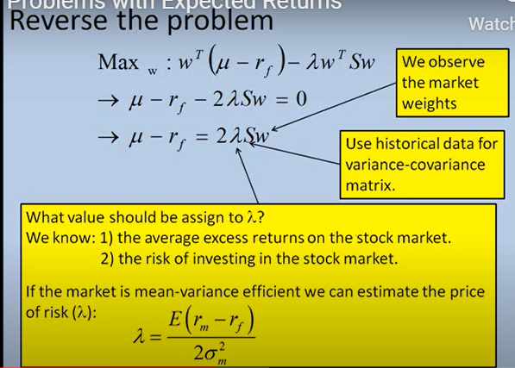

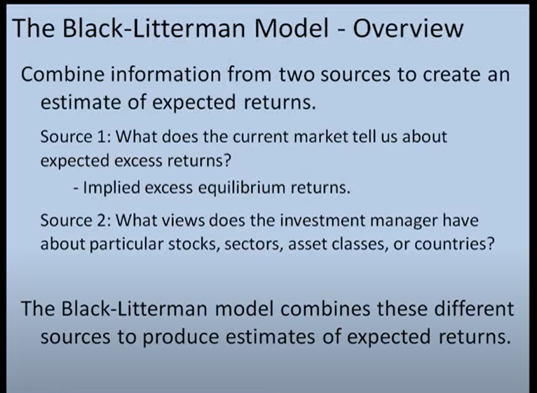

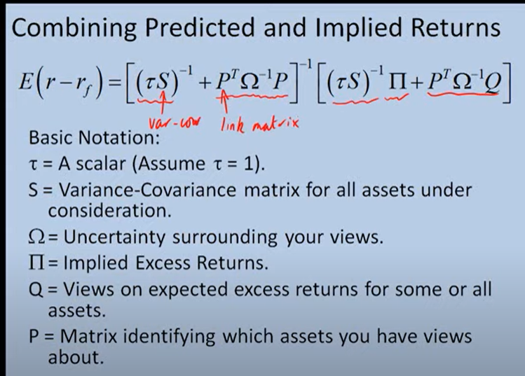

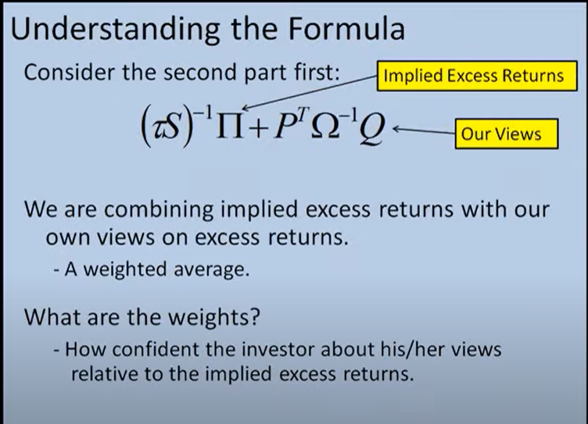

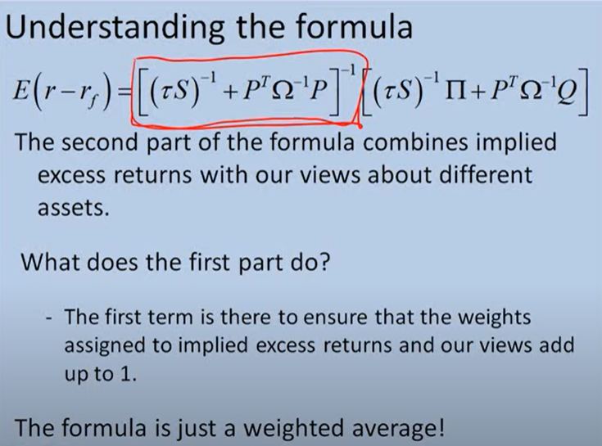

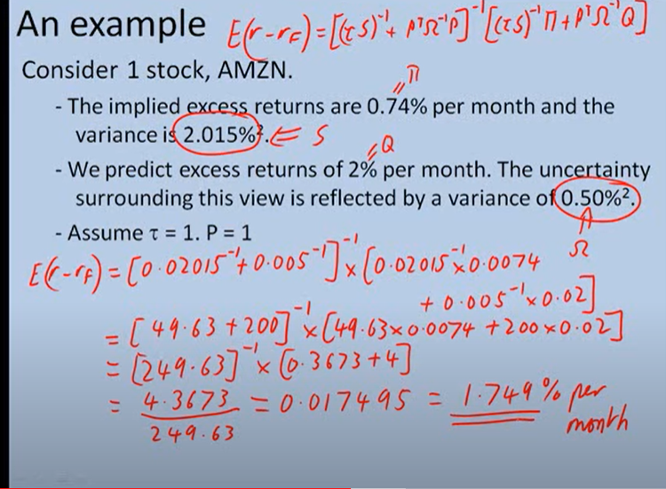

**Based on research document : Asset Allocation with Black-Litterman in a case study of Robo Advisor Betterment**